CLASS OF 1983

April 11, 2018

Greetings Classmates:
In approximately 35 days we will celebrate 35 years since we graduated from Morgan State University. It’s hard to believe that so much time has gone by. And though the campus looks very different, it brings back wonderful MORGAN MEMORIES when visiting the yard!
We hope you’ll return on May 18th for the 78th Annual Alumni Luncheon and Class Reunion. You can purchase tickets in advance by contacting the Alumni Relations Office at (443)-885-3015 or online at: https://securelb.imodules.com/s/1192/16/interior.aspx?sid=1192&gid=1&pgid=683&cid=2044

This is our year and our time to shine! The financial goal for the Class of 1983 is to raise $35,000 by December 2018. Please make a contribution today and designate your gift to any area of Morgan. Simply remember to mention the Class of 1983 in the memo section of your check/credit card payment to ensure our class receives credit.
With all of us working together, we can make great things happen for the students of Morgan and the MORGAN MEMORIES of ’83. We’re counting on your active participation and financial contribution.
Thanks so much for your support and we look forward to seeing you see at the luncheon!
Morgan Forever,
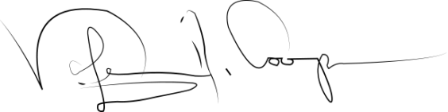
Valerie A. Cooper
Class of 1983 President
vcooper1018@gmail.com

